Dataset Description

Project Title-
Power Demand Forecasting Using Machine Learning and Time Series Models

Dataset Name
PJMW Hourly Power Consumption Dataset

Dataset Source
The dataset contains historical hourly electricity demand data for the PJM West (PJMW) region. It is provided as an Excel file named PJMW_MW_Hourly.xlsx.

Data Quantity and Quality
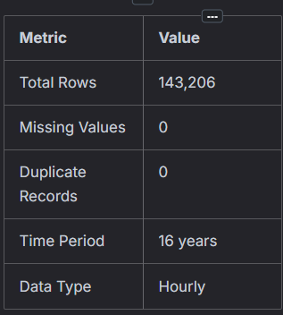

Dataset Objective
The objective of this dataset is to forecast future hourly power demand using historical electricity consumption data. Accurate forecasting helps electricity providers optimize power generation, improve grid stability, and efficiently allocate energy resources.

Target Variable
PJMW_MW – Hourly electricity demand measured in Megawatts (MW).

Features Used
Feature | Description
Hour | Hour of the day (0–23)
DayOfWeek | Day of the week (0–6)
Month | Month of the year
Year | Year of observation
DayOfYear | Day number within the year
weekofyear | Week number of the year
Is_Holiday | Indicates whether the day is a holiday (1 = Holiday, 0 = Non-Holiday)
lag_24 | Power demand recorded 24 hours earlier
lag_168 | Power demand recorded 168 hours (7 days) earlier
rolling_mean_24 | Rolling mean of power demand over the previous 24 hours
rolling_std_24 | Rolling standard deviation of power demand over the previous 24 hours
Data Preprocessing
The following preprocessing steps were performed before model training:
- Loaded the dataset from an Excel file.
- Converted the date column to DateTime format and used it as the index.
- Generated time-based features such as Hour, Month, Year, Day of Week, Day of Year, and Week of Year.
- Created lag features (24-hour and 168-hour lags).
- Created rolling statistical features (24-hour rolling mean and rolling standard deviation).
- Removed missing values generated during feature engineering.
- Split the dataset into training and testing sets using a time-based split.
Exploratory Data Analysis (EDA)
The following analyses were performed:
- Distribution of hourly power demand
- Monthly power consumption analysis
- Average hourly energy consumption
- Holiday vs. Non-Holiday consumption comparison
- Summer vs. Winter energy consumption
- Time-series trend analysis
- Seasonal decomposition
- Autocorrelation analysis
- Stationarity testing using the Augmented Dickey–Fuller (ADF) test

Machine Learning and Time Series Models Used
Model | Purpose
Linear Regression | Baseline Machine Learning Model
Random Forest | Ensemble Learning Model
XGBoost | Gradient Boosting Model
LightGBM | Efficient Gradient Boosting Model
SARIMA | Statistical Time-Series Forecasting Model

Model Evaluation
The models were evaluated using standard regression metrics such as:
- Mean Absolute Error (MAE)
- Root Mean Squared Error (RMSE)
- R² Score (Coefficient of Determination)
Actual versus predicted values were also compared to evaluate forecasting performance.

Tools and Technologies
- Python
- Pandas
- NumPy
- Matplotlib
- Scikit-learn
- XGBoost
- LightGBM
- Statsmodels

Applications
This dataset can be used for:
- Short-term electricity demand forecasting
- Smart grid management
- Energy resource planning
- Load balancing
- Peak demand prediction
- Power generation scheduling

Conclusion
The processed dataset was successfully used to build and evaluate multiple machine learning and time-series forecasting models. Feature engineering, preprocessing, and model comparison improved forecasting performance and enabled accurate prediction of future hourly electricity demand.

